HTTP Status Codes:

1. 101 – Switching Protocol
2. 200 – Ok
3. 302 – Not Modified

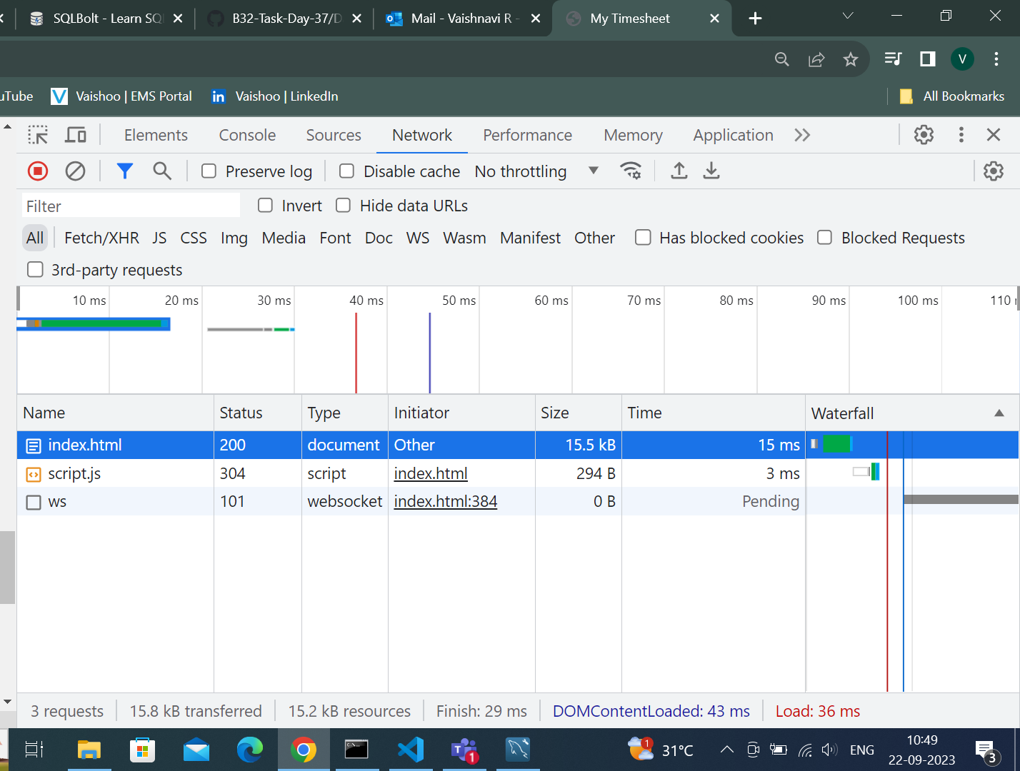

1. 404 – Not found

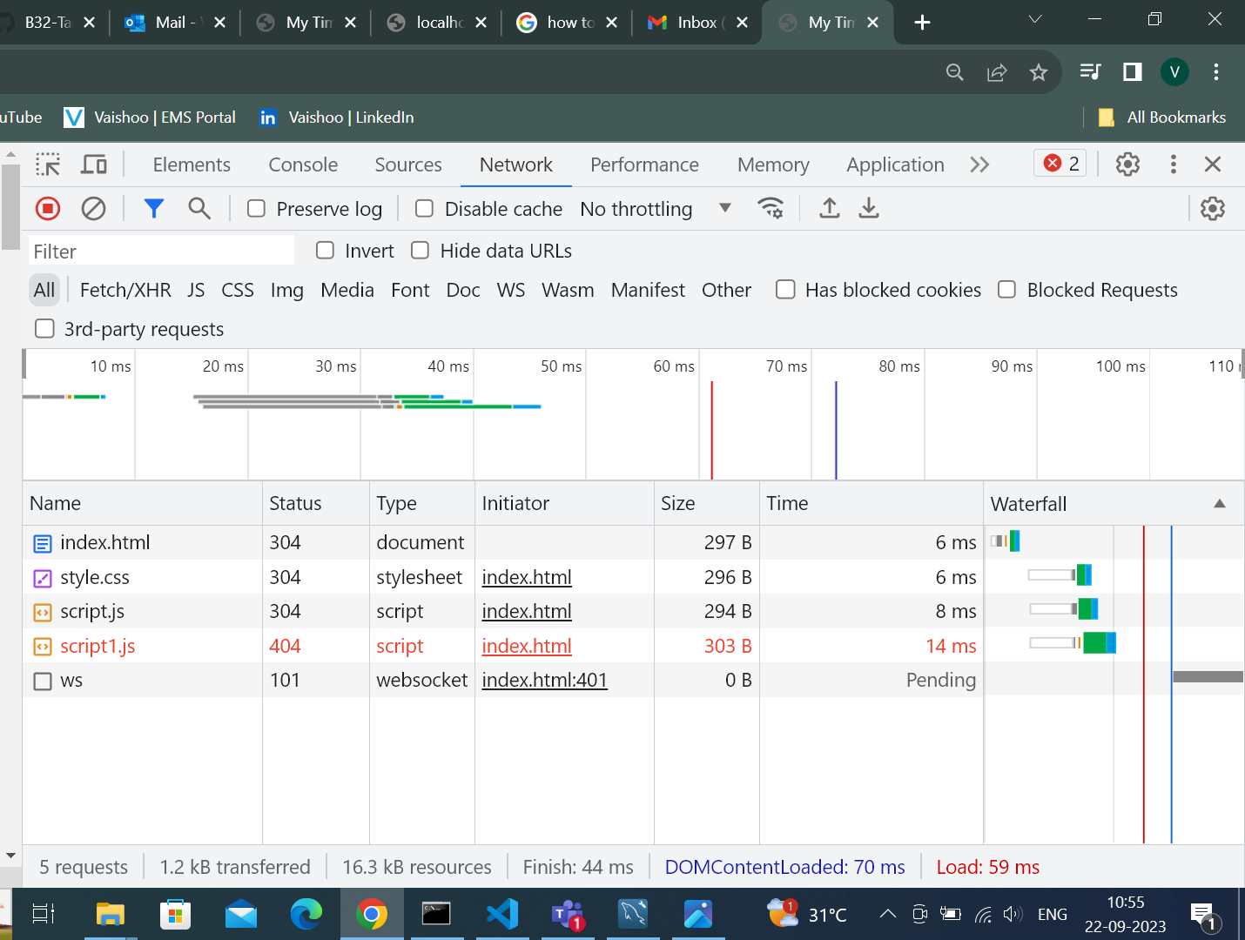

1. 500 - Internal Server Error

